**Project Documentation**

An Analysis on Audible Books Using Excel And Power BI

# 1. Project Overview

This project analyses the audible book data using the Excel and Power BI to identify trends, generate insights, and improve business decisions. It aims to provide meaningful insights into book releases, author performance, and books from high to low price

# 2. Tools Used

* Microsoft Excel
* Power BI

# 3. Dataset

* Sample Data: Audible-uncleaned <https://drive.google.com/file/d/1Nw56QcBrlZ-7tc5MFdgZEXZ6q5J9jjAt/view?usp=sharing>

Data contains:

* Book Name – Title of The Audiobook
* Author – Name of The Author
* Narrator – Person Who Narrated the Audiobook
* Time – Duration of The Audiobook (E.G., 02:20:00)
* Release Date – Date the Audiobook Was Released
* Language – Language of The Audiobook (E.G., English)
* Stars – Star Rating (E.G., "5 Out Of 5 Stars")
* Ratings – Number of User Ratings (E.G., "10 Ratings")
* Price – Price of The Audiobook (Numeric, In ₹)

# 4. Steps Followed

* Cleaned data in Excel and Power Bi Power Query Editor (e.g., removed blanks, formatted columns) <https://drive.google.com/file/d/1ypJLKyWasl59uuPNbez7-8OMXgDHQXRy/view?usp=sharing>
* Imported cleaned data into Power BI
* Built dashboards using charts, slicers, and KPIs <https://drive.google.com/file/d/1s8UHZTxGfFgkmDPWPhmrzfcPVwewB7OV/view?usp=drive_link>

# 5. Key Insights

* The average star rating of all audiobooks is 4.46 out of 5, indicating high overall customer satisfaction.
* Some of the highest-priced or top-selling books include: *Tales of Horror and Suspense* – ₹949.4, *Capital Volume 3* – ₹874.7, *Sherlock Holmes: The Definitive Collection* – ₹837.1, *The Wealth of Nations* – ₹788.8, *The Brothers Karamazov* – ₹757.3.
* Most books have, Below 1K ratings.
* The average audiobook price is ₹699.3, suggesting a moderate pricing strategy across the catalog.
* Sharp increase in audiobook releases between 2015 and 2020, The year 2019 marked most Releases

6. **Screenshots**

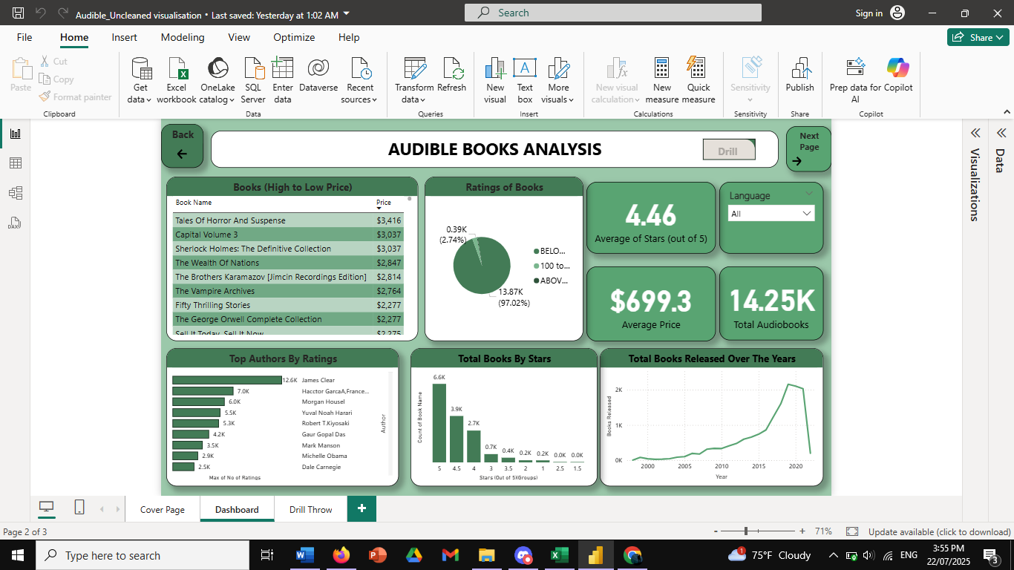

# 7. Files Included

* ‘– Cleaned data and basic analysis file

<https://drive.google.com/file/d/1ypJLKyWasl59uuPNbez7-8OMXgDHQXRy/view?usp=drive_link>

* ‘Mini Project Report File <https://drive.google.com/file/d/1s8UHZTxGfFgkmDPWPhmrzfcPVwewB7OV/view?usp=sharing>

# 